1.uniqush/uniqush-push
- Stand alone server program dedicated to push service, which means you can run it on your own server.
- Multiple platforms supported for popular smart phone systems including android, iOS, etc. And we will support more in the future.
- Simple and unified interface for Apps’ server developers. You don’t need to care about receiver’s system, simply send an HTTP request to uniqush server and it will do all things for you.
- No need to implement re-send on failure mechanisms, uniqush will re-send the notification on a recoverable error whenever possible.
- Wildcard multicast, so that you can group your users and multicast notifications to specific group.
- Native multicast support
- Q: A general push notification platform for all systems? How does this differ from services like urbanairship?
- A: urbanairship is a great service, and there're other similar services available, like openpush, notifica, etc. All of them are wonderful services. However, uniqush is different from them. Uniqush is not a service. Instead, Uniqush is a system, which runs on your own server. In fact, if you wish, you can use uniqush to setup a similar service like urbanairship.
- Q: OK. Then is it a library? Like java-apns?
- A: Well.. Not actually. I mean, it is a program, like apache httpd. You download it, you run it, that's it. You don't need to worry about which language to use, package dependencies, etc.
- Q: But wait, how can I use it anyway? I mean, if my program wants to push something, I need to tell uniqush about this action. How can I communicate with uniqush? There must be some library so that I can use it in my program to talk with uniqush, right?
- A: We are trying to make it easier. uniqush-push provides RESTful APIs. In other words, you talk with uniqush-push through HTTP protocol. As long as there's an HTTP client library for your language, you can use it and talk with uniqush-push. For details about the our RESTful APIs, you may want to check out our document.
- Q: Then that's cool. But I noticed that you are using Go programming language. Do I need to install Go compiler and other stuff to run uniqush-push?
- A: No. There is no dependency. All you need to do is to download the binary file from the download page and install it. You only need to have a redis database running somewhere so that uniqush-push can store the user data in redis. For more details, here is the installation guide
- Q: This is nice. I want to give it a try. But you are keep talking about uniqush-push, and I'm talking about uniqush, are they the same thing?
- A: Thank you for your support! Uniqush is intended to be the name of a system which provides a full stack solution for communication between mobile devices and the app's server. uniqush-push is one piece of the system. However, right now, uniqush-push is the only piece and others are under actively devlopment. If you want to know more details about the uniqush system's plan, you can read the blog post. If you want to know the latest progress about uniqush system, please check our blog. And if you are really impatient, our github account will always contain the latest progress.

2.Great Mobile Engagement, Delivered | Urban Airship
https://www.urbanairship.com/products/engage/features
- Location Targeting
- Dynamic Segmentation
- Scheduling
- Analytics and Reporting: Know What Works
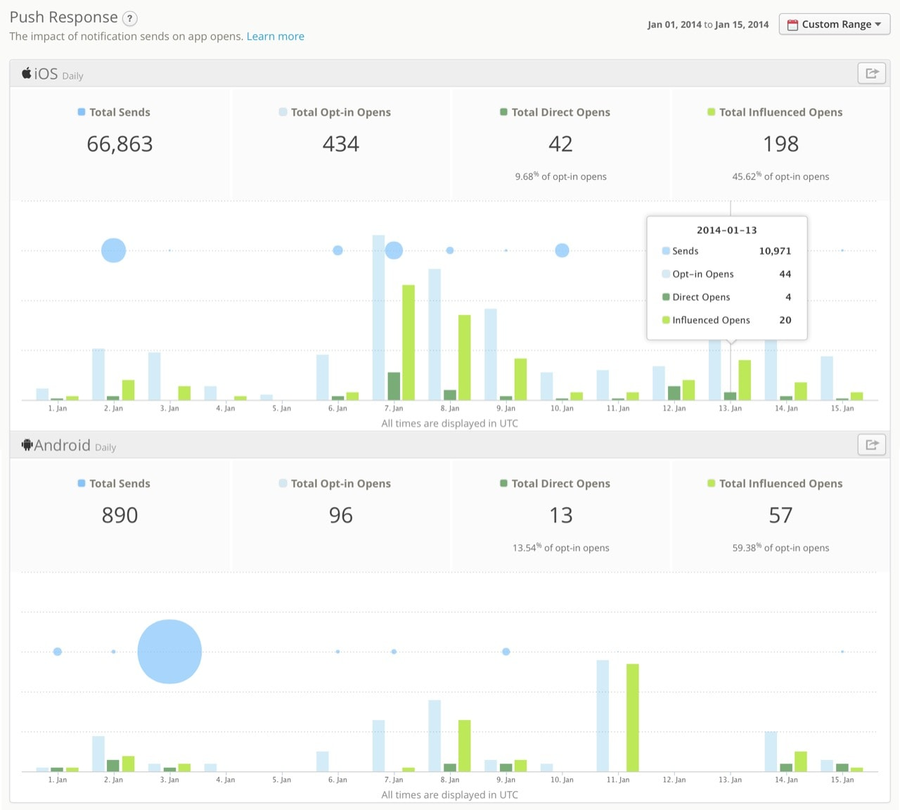
Next
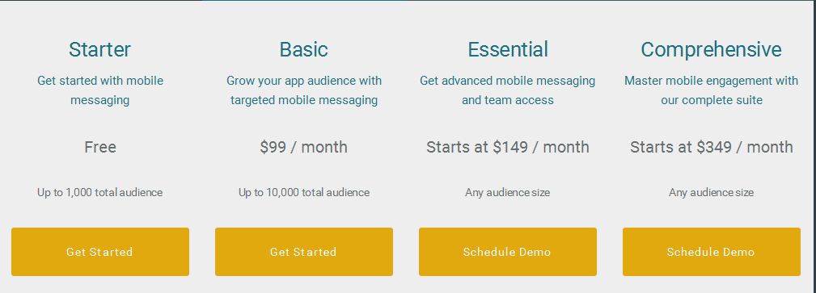

3.npm: node-pushserver
- Manages several applications
- Allow to regroup several applications as a single target for notifications
- Send notifications to one application or to several applications at the same time using target
- Filter the devices you want to notify with custom criteria
- Testing capabilities : simulate the sending of notifications, send a notification to a single device
- Simple GUI for configuring applications & targets, viewing the registered devices, sending notifications and viewing already sent notifications
- Rest API

4.https://www.pushwoosh.com/
- Scheduling tab
- Start A/B Test
- Filter Tab
- Platform specific tab
- Huge volumes
- Deep segmentation
- Private cloud
- Timezone sensitive
- High speed
- Statistics & analytics
- Push scheduling
- Geolocation push
- Other Features
Badges: an iOS badge number you would like to send with your push. Use +n / -n to increment / decrement the current badge value. Sending 0 clears the badge from your app’s icon.
Sound: here you can specify the name of a custom sound file in the main bundle of your application.
iOS8 Category: select a Category with the set of buttons for iOS8.
iOS Root Params: Root level parameters to the APS dictionary.
Check Send silent notification if you need to send a silent push with content-available property. When a silent push arrives, iOS wakes up your app in the background so that you can get new data from your server or do background information processing.
Check Newsstand notification to send push to your iOS newsstand application.
Expiration time: set the period after which the push won't be delivered if the device was offline.

5.https://parse.com
- Sending Pushes
You can view your past push notifications on the Parse.com push console for up to 30 days after creating your push. For pushes scheduled in the future, you can delete the push on the push console as long as no sends have happened yet. After you send the push, the push console shows push analytics graphs.
- Using Channels
The simplest way to start sending notifications is using channels. This allows you to use a publisher-subscriber model for sending pushes.
- Sending Pushes to Channels
In the iOS/OS X SDK, the following code can be used to alert all subscribers of the "Giants" channel that their favorite team just scored.
- Using Advanced Targeting
While channels are great for many applications, sometimes you need more precision when targeting the recipients of your pushes. Parse allows you to write a query for any subset of your Installation objects using the querying API and to send them a push.
- Saving Installation Data
Storing data on an Installation object is just as easy as storing any other data on Parse. In our Baseball app, we could allow users to get pushes about game results, scores and injury reports.
- Sending Pushes to Queries
Once you have your data stored on your Installation objects, you can use a PFQuery to target a subset of these devices.
- Sending Options
- Customizing your Notifications
alert: the notification's message.
badge: (iOS/OS X only) the value indicated in the top right corner of the app icon. This can be set to a value or to Increment in order to increment the current value by 1.
sound: (iOS/OS X only) the name of a sound file in the application bundle.
content-available: (iOS only) If you are a writing a Newsstand app, or an app using the Remote Notification Background Mode introduced in iOS7 (a.k.a. "Background Push"), set this value to 1 to trigger a background download.
category: (iOS only) the identifier of th UIUserNotificationCategory for this push notification.
uri: (Android only) an optional field that contains a URI. When the notification is opened, an Activity associate with opening the URI is launched.
title: (Android, Windows 8, and Windows Phone 8 only) the value displayed in the Android system tray or Windows toast notification.
- Setting an Expiration Date
- Targeting by Platform
If you build a cross platform app, it is possible you may only want to target devices of a particular operating system. Advanced Targeting allow you to filter which of these devices are targeted.
- Scheduling Pushes
- Receiving Pushes
As we saw in the Customizing Your Notification section, it is possible to send arbitrary data along with your notification message. We can use this data to modify the behavior of your app when a user opens a notification. For example, upon opening a notification saying that a friend commented on a user's picture, it would be nice to display this picture.
- Responding to the Payload
- Tracking Pushes and App Opens
- Tracking on OS X
- Notifications (iOS only)
To track analytics around local notifications
- Clearing the Badge
- Push Experiments
- A/B Testing
- Experiment Statistics
- Test Audience Size
- Confidence Interval
- Push Localization
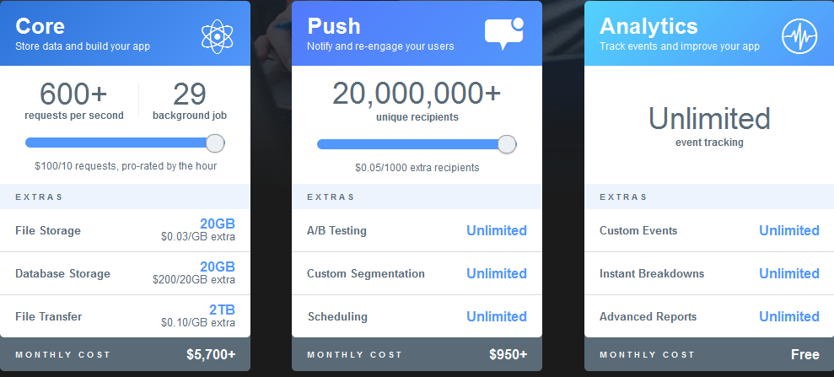

6.https://github.com/davibennun/laravel-push-notification
This library is not suitable for APNS when sending a large number of notifications

7.Ph3nol/NotificationPusher
https://github.com/Ph3nol/NotificationPusher/issues/54
This library is not suitable for APNS when sending a large number of notifications

